Unit 1

1. Which are different primitive operations of stack? Give examples.
2. **What is time complexity and space complexity? Which notations are used measure time complexity?**
3. **Write an algorithm for different operations used in stack.**
4. **Convert the following expression into postfix form. Evaluate the obtained postfix expression using stack.**

**2-3+4-5*6**

1. **Apply stack and evaluate a given postfix expression  
    2 4 + 4 6 + \***
2. **Define list, circular list, header node, doubly linked list.**
3. **Write an algorithm for evaluation of postfix expression.**
4. **Apply push and pop operation to add and remove following data in the stack. Also define stack.  
   add (K)   
   add (H)  
   add (M)  
   remove two elements**
5. Which are different linear and nonlinear data structures? Give example of each.
6. **Convert the following expression in postfix form  
   (A + B) * C - (D - E) * (F + G)**
7. Compare array based and linked list based stack implementation.
8. **Which are different types of data structures? Explain.**
9. Which are different applications of stack?
10. Write an algorithm for implementation of following operations  
    Push   
    pop  
    Emptystack  
    fullstack  
      
      
    Unit II
11. Define queue and priority queue. Write algorithm to implement queue operations.
12. Which data structure is used for dictionary a0nd spell checker? Justify your answer.
13. Compare singly linked list, doubly linked list and circular linked list. Write steps to implement insert and delete operations of linked list.
14. Define singly linked list, doubly linked list and circular linked list.
15. How to implement linked list using dynamic memory allocation.
16. Write steps to implement two operations of following data strcutures  
    stack  
    queue  
    priority queue  
    linked list  
    trees
17. Describe Insertion and Deletion operations in linked list to insert and delete first node, last node and nth node.
18. Describe insertion and deletion operations in linked list to insert and delete first node, last node and nth node.
19. What is queue? How it is different from stack and how it is implemented?
20. Write applications of each stack and queue and linked list.
21. Explain linked list implementation.
22. Compare use of array and dynamic memory for linked list implementation.
23. **Convert given infix expression to prefix  
     A + B * C – D + E / F / (G + H)**
24. **Convert given infix expression to postfix  
     A + B * C – D + E / F / (G + H)**
25. Write an algorithm to implement operations  
    Push  
    pop
26. Describe insertion and deletion operation in linked list as first node, last node and nth node.
27. Write getnode and freenode operations and apply it to insert and remove a node.  
      
    Unit IV
28. Write an algorithm for merge sort
29. Write an algorithm for bubble sort
30. Write an algorithm for quick sort
31. Write an algorithm for insertion sort
32. Write an algorithm for heap sort
33. **Sort the following values using merge sort method  
    23 4 12 5 4 7 9 15**
34. **Sort the following values using bubble sort method  
    23 4 12 5 4 7 9 15**
35. **Sort the following values using quick sort method  
    23 4 12 5 4 7 9 15**
36. Sort the following values using heap sort method  
    23 4 12 5 4 7 9 15
37. Sort the following values using radix sort method  
    23 4 12 5 4 7 9 15
38. **Sort the following values using selection sort method  
    23 4 12 5 4 7 9 15**
39. Compare sequential search and binary search.
40. Search number 7 in the following list using binary search method.  
    23 4 12 5 4 7 9 15
41. Write an algorithm for binary search.
42. Compare different sorting methods based on their complexity.  
      
    Unit III
43. Define binary tree, threaded binary tree.
44. Which are different methods used for traversing binary tree.
45. Explain preorder, postorder and inorder traversal methods.
46. Traverse thefollowing tree using preorder, postorder and inorder traversal methods.

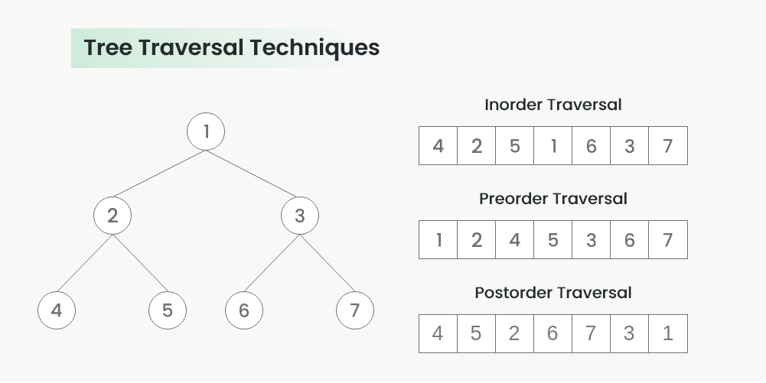

1. Write any two applications of binary tree. Create the binary search tree using following data  
   **43, 10, 79, 90, 12, 54, 11, 9, 50**
2. Which operations are used in binary tree? Explain.  
     
     
   Unit V
3. Write algorithm for BFS traversal
4. Write an algorithm for DFS traversal
5. Compare BFS and DFS methods with example
6. Traverse the following graph with BFS
7. 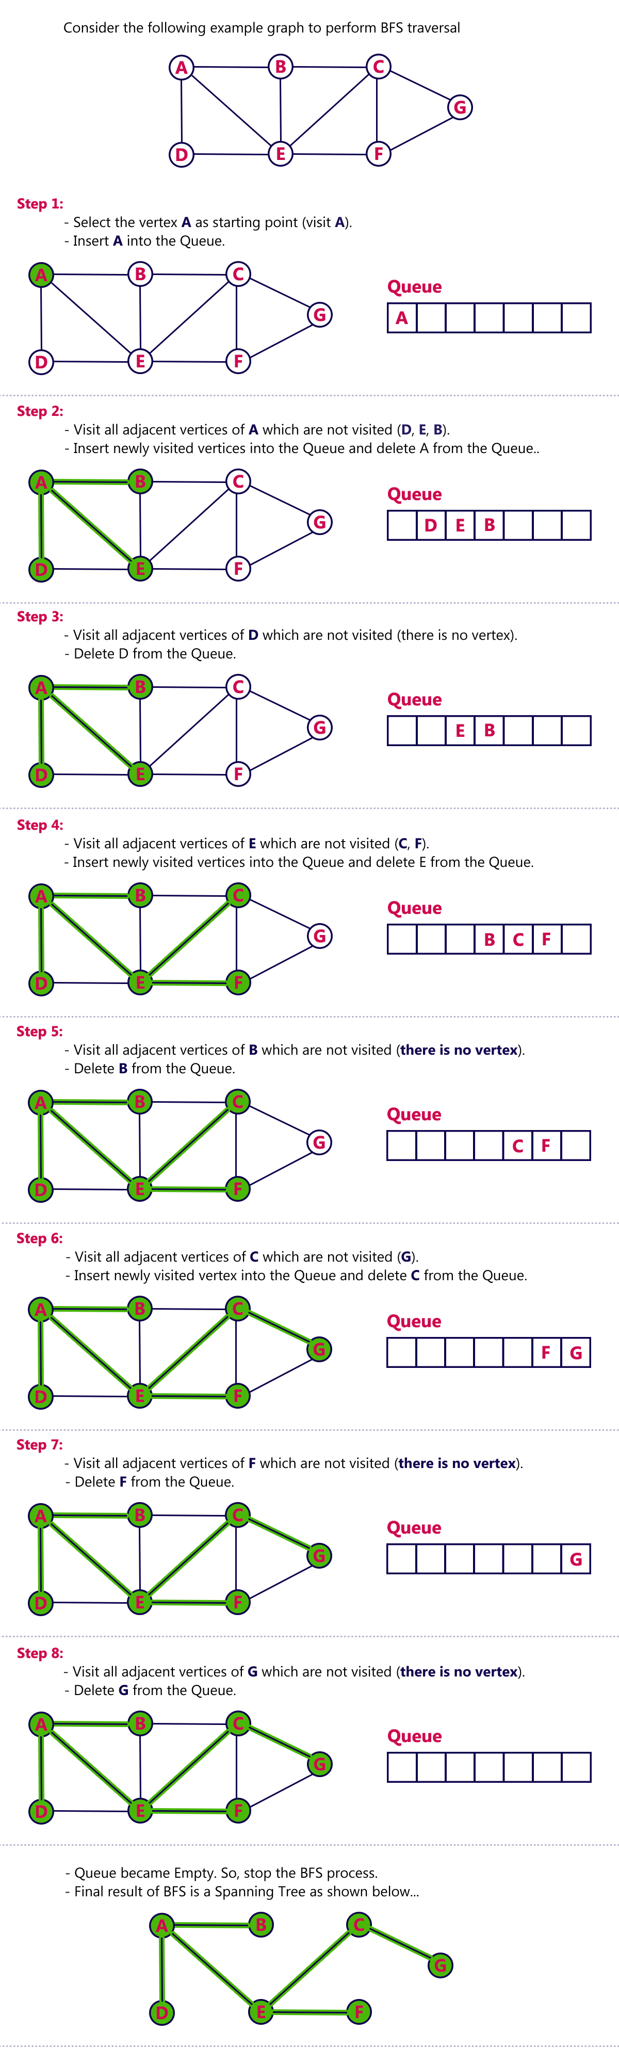
8. **Traverse the following graph with BFS  
   **
9. Explain BFS and DFS methods.
10. **Traverse the following graph using Breadth First Search Technique (Consider vertex S as starting point)  
    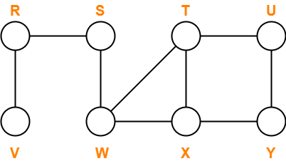**
11. **Traverse the following graph using depth First Search Technique (Consider vertex S as starting point)**
12. **Find minimum spanning tree with Prim’s algorithm for the following graph.**

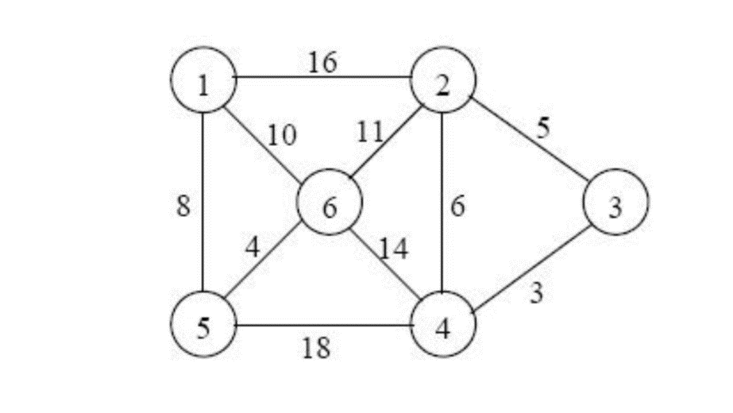

1. **Find minimum spanning tree with Kruskal’s algorithm for the following graph.**



1. Define spanning tree. Write an algorithm to find minimum cost spanning tree with Kruskal’s algorithm.
2. Write Dijkstra's algorithm for shortest path.
3. Find shortest path from source to all nodes with Dijkstra’s algorithm. Consider 0 as source node.

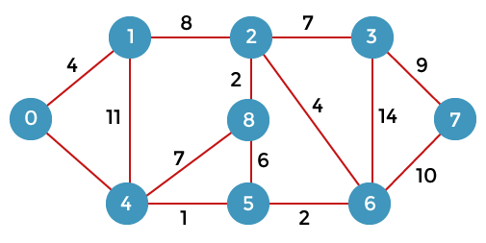

1. Which are different graph representation methods? Explain.
2. What is collision resolution in hashing? Give names of searching and hashing algorithms each.
3. What is hashing and searching? Which algorithms are used for hashing?
4. Compare sequential search and binary search with example.
5. Define a hash table. Explain it briefly.
6. Consider the following 4-digit employee numbers  
   9614, 5882, 6713, 4409, 1825  
   Find the 2-digit hash address of each number using  
   a) the division method, with m=97  
   b) the midsquare method.  
   c) the folding method without reversing.  
   d) the folding method with reversing.